About VPadel

* VPadel is part of the GoSportz group, which is the leading brand in the Sports Infrastructure space in India.
* Brought the sport of Padel to Mumbai, India in August 2021 & set up the first court at Acres Cub in Mumbai in August 2021. Simultaneously set up two Courts at Legends Sports Academy in Pune in August 2021. A third court was set up at MSLTA in Mumbai in January 2022.

Vision

* Expand the sport of Padel
* Make Padel the preferred racquet sport
* Assist in building the National Team Program

Mission

* Promote and develop Padel in India, Middle East & Asia
* Offer Quality Padel services
* Create and expand Padel communities

Objectives

* The be the pioneer of Padel solutions in India, Middle East & Asia
* Continuous improvement of our products and services
* Encourage all players to participate in tournaments
* Build strong relationships with our clients

Padel Court Rates :=

VPadel Centre, MSLTA, Mumbai

Monday to Friday

- ₹ 800 per hour (without lights)

- ₹ 1200 per hour (under lights)

Saturday

* ₹ 800 per hour (without lights)
* ₹ 1000 per hour (under lights)

Sundays & Public Holidays

* ₹ 1000 per hour (without lights)
* ₹ 1400 per hour (under lights)

VPadel Centre, The Acres Club, Mumbai

Monday to Sunday

- ₹ 600 per hour (without lights)

- ₹ 800 per hour (under lights)

VPadel Centre, Legends Sports Complex, Pune

Monday to Sunday

- ₹ 600 per hour (without lights)

- ₹ 800 per hour (under lights)

Padel Coaching Programme

VPadel is proud to have tied up with the leading Padel Academy in the world, The Hello Padel Academy. We believe that to enjoy the sport & play it for a long time, technical training is important. Our endeavour in this tie-up is to provide a systematic & professional method of teaching. We will provide online as well as offline coaching for Beginners to Advanced Level. We will also provide coaching programmes to coaches who would like to get into the profession of Padel Coaching.

* Beginners – for Juniors & those who are just starting Padel. Mainly group training.
* Intermediate – for Players with basic skill level who want to go to the next level. Combination of group & individual training.
* Advanced – Players with advanced skill levels, who would like to work towards playing on the National, International Circuit. Individual training with the focus onspecific skill & strategy development is provided.

For more details please contact :- [training@vpadel.in](mailto:training@vpadel.in) (need to create the id)

Coaching Venues :-

* VPadel Centre, The Acres Club. Mumbai

VPadel Membership Packages :-

* In order to make the VPadel experience more rewarding , we will be introducing various membership packages. The membership would have the following benefits :-
  + VPadler’s Welcome kit
  + SpecialPricing for Court Booking
  + Invitation to Special VPadel Events
  + Access to VPadel Lounges (at select centres)
  + Discount on Food & Beverages
  + Special discounts on Padel Equipment & Accessories
  + Discounts on Coaching Programs (Local & International)
  + Direct access to VPadel National League
  + Other benefits as VPadel grows Nationally & Internationally

Please register your interest at [membership@vpadel.in](mailto:membership@vpadel.in) (need to create an id)

Padel Packages

* You want to play more Padel, VPadel makes it more rewarding
  + Bronze Package - Buy 10 hours &play for 11hours
  + Silver Package - Buy 20 hours &play for 23 hours
  + Gold Package - Buy 30 hours &play for 35 hours
  + Platinum Package - Buy 50 hours &play for 60 hours

TERMS:-

* The packages must be pre-paid
* The total hours (including free hours) must be consumed within 30 days of package purchase
* The total amount paid will be adjusted based on court charges at the time & location of use

FACILITIES :-

* VPadel Centre, The Acres Club, Mumbai
* VPadel Centre, MSLTA, Mumbai

Court Types :-

goPadel isdedicated to the manufacturing of Premium Padel Courts with the primary goal to create something very innovative and efficient, to be a key leader in the market of very high-quality Padel Courts.

After having distributed and installed Padel Courts from different manufacturers during the last years, we understood clearly the improvements we wanted to make in our courts. Not only on the quality of the court but also the aesthetic, transportation cost, installation, and many other aspects.

Through our R&D department, where we are constantly thinking about improving our product, as well as introducing new designs, also allows us to make exclusive designs to our clients with all the branding possibilities. We pay special attention to all our clients, having plenty of options that we give them to brand their court and create their own identity.

**COURT MODELS**

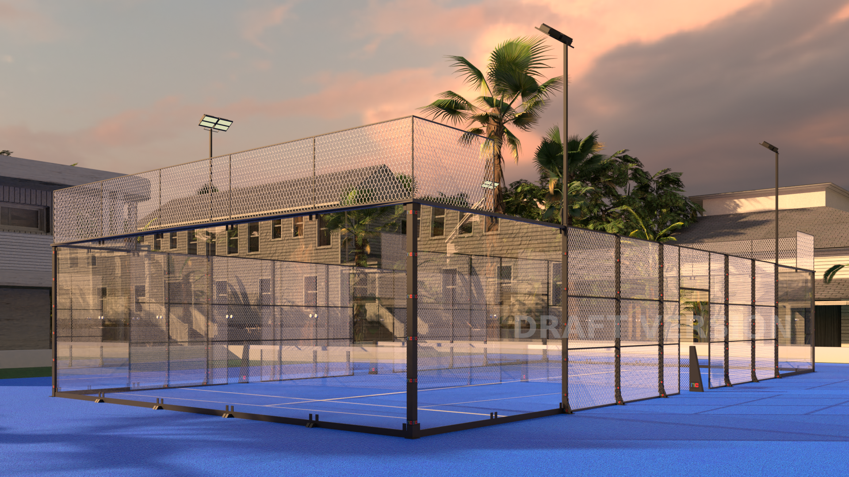

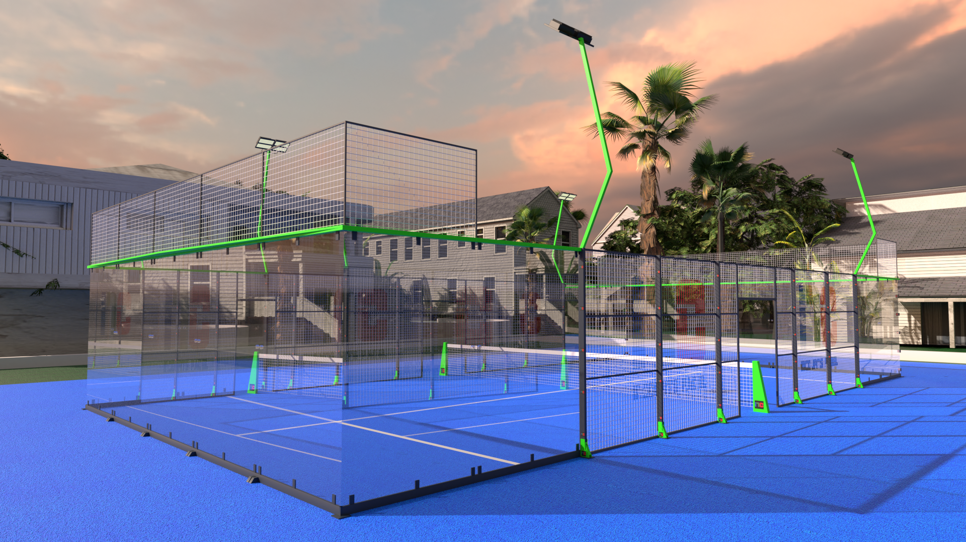

**goPadel***SUPER PRIMA* **goPadel***PRIMA*

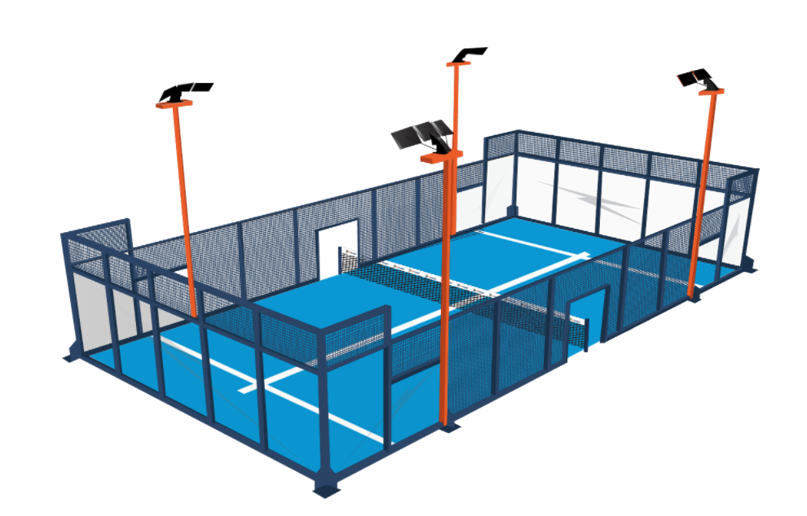

g

**goPadel***BASICO*

*Advantage goPadel :-*

* Innovative Designs
* Customisable options
* High Quality Raw Material
* Galvanised Structure
* Certified Glass Panels
* High Quality Padel turf
* Courts designed & built as per International Padel Standards